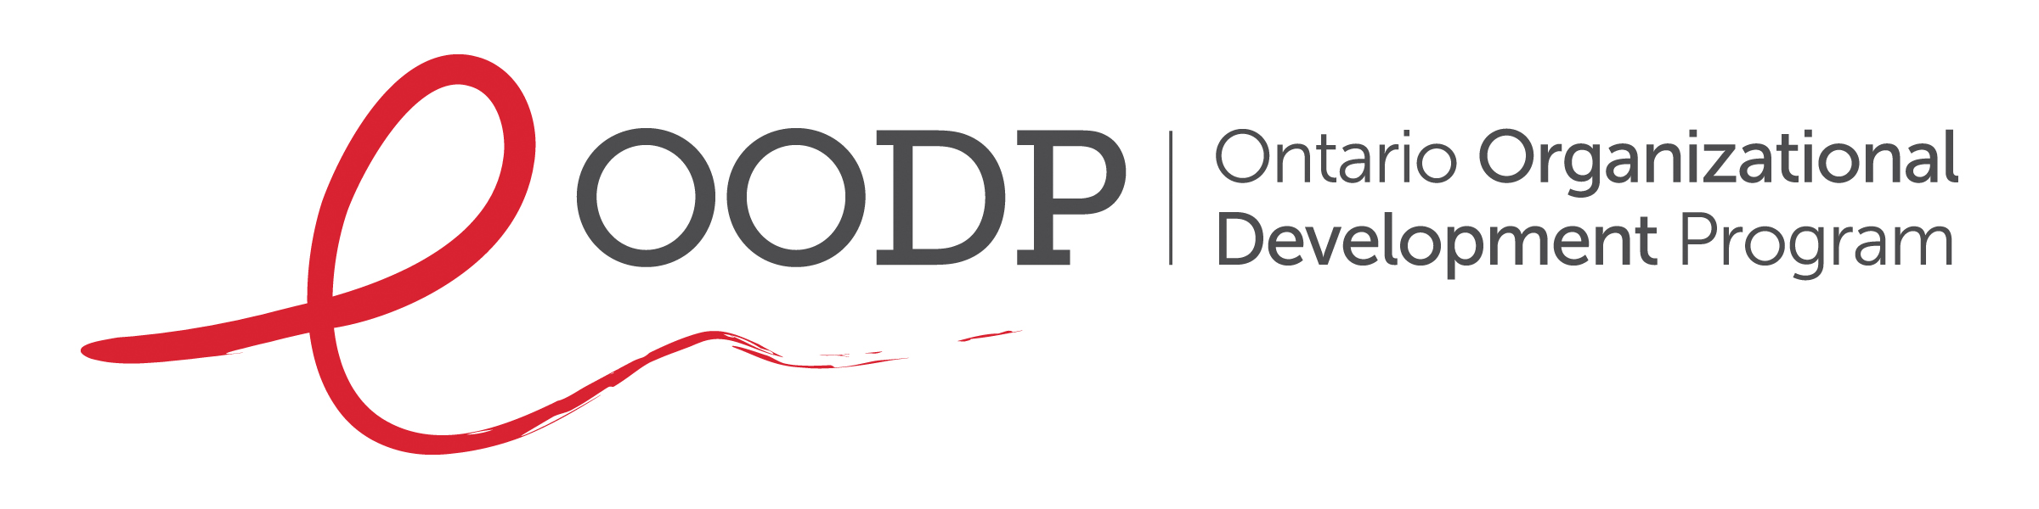
Staff Workplan Guide

Prepared by: Dionne A. Falconer, OODP Consultant, June 2016

Revised by: Radha Nayar, OODP Director, May 2026

Copyright Statement

Production of the Staff Workplan Guide has been made possible through financial contributions by the HIV and Hepatitis C Programs (HHP), Ontario Ministry of Health.

Copyright to the Production of the Staff Workplan Guide has been made possible through financial contributions by the HIV and Hepatitis C Programs (HHP), Ontario Ministry of Health.

Copyright to the Staff Workplan Guide is held by the Ontario Organizational Development Program (OODP). The OODP acknowledges the contributions of its consultant, Dionne Falconer, in preparing this document. The OODP encourages the use of the Production of the Staff Workplan Guide has been made possible through financial contributions by the HIV and Hepatitis C Programs (HHP), Ontario Ministry of Health.

Staff Workplan Guidelines
A workplan is a document that maps out the proposed steps for how a goal will be accomplished, including who will be involved and
timelines. It can be created for use by an individual or group. It can contain high-level or very detailed information depending on the purpose of the workplan and the requirements of its user.

This document is intended for use by individual staff working in the HIV sector. It can also be used by a staff team. It is a planning tool to complement the other planning documents used by the organization, including the strategic plan and implementation plan. It is a leading practice for an organization to have a strategic plan to focus its priorities and ensure everyone in the organization is working towards the same goals. It is also good practice to have an implementation plan to guide the execution of the strategic directions in the strategic plan. The figure below shows the relationship between the organization’s mission and planning documents.

Figure 1: Relationship between Organization’s Mission and Planning Documents

Each staff person should have a workplan. It should be reviewed and updated annually and contain activities that will contribute to achieving the mission of the organization. When developing the workplan, the following should be considered to identify and incorporate relevant activities into the workplan:
- Job description;
- Program goals and relevant evaluation information;
- Strategic directions in the organization’s current Strategic Plan;
- Obligations from funding agreements; OACHA’s HIV Action Plan to 2030, Closing the Gaps in the HIV Care Cascade in Ontario
- including the focus on populations most affected by HIV and the HIV Prevention, Engagement and Care Cascade; and
- Events, initiatives or other activities that require planning.

Figure 2: Considerations to Inform Staff Workplan Content

Grounding Staff Work Planning in Anti-racism, Anti-Black Racism, Anti-oppression and Reconciliation Practices

Many organizations in the HIV sector in Ontario have reflected anti-racism, anti-Black racism and Reconciliation with Indigenous communities in their Strategic Plans and Implementation Plans. This reflection is grounded in the core values held by the HIV sector and AIDS Service Organizations (ASOs) and acknowledges the reality that systemic racism continues to shape who is disproportionately impacted by HIV and AIDS in the communities we serve.

It is equally important that individual and team workplans reflect anti-racism, anti-Black racism and Reconciliation practices. Staff workplans create a bridge between organizational priorities and day-to-day actions. Embedding these commitments into staff goals, responsibilities and activities helps ensure that programs, services and workplace practices are equitable, responsive and accountable to the communities most impacted.

Through staff work planning, individuals and teams can:
- Create activities and approaches that intentionally engage diverse voices in service planning and service delivery;
- Identify who may be underserved or excluded from programs and services, and consider why;
- Design and deliver services that better meet the needs of Black, Indigenous and other racialized communities;
- Contribute to creating safer, more equitable and inclusive environments for clients, peers and volunteers;
- Build accountability into individual and team goals through measurable actions and clear expectations;
- Integrate anti-racism, anti-oppression and Reconciliation practices into everyday work through both actions and workplace culture.

This Work Planning Guide applies an explicit anti-racism and equity-focused lens to support staff and teams in embedding these principles into annual workplans, activities and priorities. Staff are encouraged to identify and address barriers experienced by Black, Indigenous and other marginalized communities within their areas of responsibility. The goal is to ensure that, alongside operational effectiveness, staff workplans actively advance racial equity, social justice and Reconciliation with Indigenous communities.

Before finalizing individual or team goals and activities, consider:
- Who will benefit most from this goal or activity?
- Have perspectives from Black, Indigenous and other marginalized communities been considered or included?
- Could our goals or activities unintentionally disadvantage or exclude any population group? If so, how can those impacts be mitigated?

To prepare to complete a workplan, staff should gather any necessary information and documents related to the above. For additional information on the OACHA HIV Action Plan to 2030, please see the Appendices.

The completion of the workplan template is a 6-step process that requires identifying the following:

Below is an example of how the template should be completed.

Goal  (What) | Alignment Component  (Why) | Success Indicator  (Target) | Key Activities  (How) | Lead/ Others Involved  (Who) | Timelines/ Completion Dates  (When) | Resources Required  (Supports) | Status  (Current progress or completion level – to be completed quarterly) | Equity Considerations | Comments
Example:  Revitalize the drop-in space for queer and trans youth | Example:  Provincial Strategy Goal #1: Improve the health and well-being of populations most affected by HIV.  Strategic Direction #3: Deliver responsive programs and services | Example:  Welcoming and accessible drop-in space for queer and trans youth developed. | Example:  - Conduct evaluation on current drop-in space.  - Implement recommendations for which we have the capacity and resources  - Seek resources to implement as many remaining recommendations as possible | Example:  - Youth Worker  - Youth Worker  - Fundraiser | Example:  - May to July 2026  - September 2026  - Ongoing starting October 2026 | Example:  - Sample evaluation or questions  - Volunteers to administer survey during drop-in time  - Database of potential funders

Staff Workplan Template

[Name and position of staff or name of staff team]

[Time period covered]

Goal  (What) | Alignment Component  (Why) | Success Indicator  (Target) | Key Activities  (How) | Lead/ Others Involved  (Who) | Timelines/ Completion Dates  (When) | Resources Required  (Supports) | Status  (Current progress or completion level – to be completed quarterly) | Equity Considerations | Comments

Appendix A:
HIV ACTION PLAN TO 2030: Closing the Gaps in the HIV Care Cascade in Ontario

VISION
By 2030, new infections are rare, very few Ontarians are living with undiagnosed HIV, and all people with HIV have the treatments and
other services and supports they need to manage their health well.

GOALS
- Reduce new infections.
- Ensure everyone at risk of HIV has access to timely, high-quality, culturally responsive testing services.
- Ensure everyone diagnosed with HIV has access to timely treatment, high-quality, culturally responsive care.
- Reduce stigma, discrimination, and other barriers to optimal health, including social determinants of health.

Appendix B:
Populations Most Affected by HIV in Ontario
Early in the HIV epidemic – before the virus had been identified – HIV established itself in a small number of populations, which now have higher prevalence of HIV than others in the general population. Almost four decades later – despite the significant progress these populations have made at preventing and treating HIV – new HIV diagnoses in Ontario are still concentrated in five populations recognized by Ontario’s HIV Action Plan to 2030.
- Two-spirit, gay, bisexual, and other men who have sex with men, including trans men
- African, Caribbean, and Black populations
- Indigenous Peoples
- People who use drugs
- Cis and trans women, including those from the communities above, who face systemic and social inequities, and are more likely to be exposed to HIV through a sexual or drug using partner.
Members of these populations also face stigma, discrimination and/or other barriers related to the social determinants of health, such as poverty, housing instability, intimate partner violence, and trauma associated with homophobia, racism and colonization, that may make them more vulnerable to HIV infection and affect their ability to access services. While most people diagnosed with HIV in Ontario are members of these populations, not everyone in these populations is at risk of HIV.
Source: https://www.ohtn.on.ca/research-portals/priority-populations/

Appendix C:

Ontario, Prevention, Engagement and Care Cascade (Ontario Advisory Committee on HIV/AIDS, HV Action Plan to 2030)

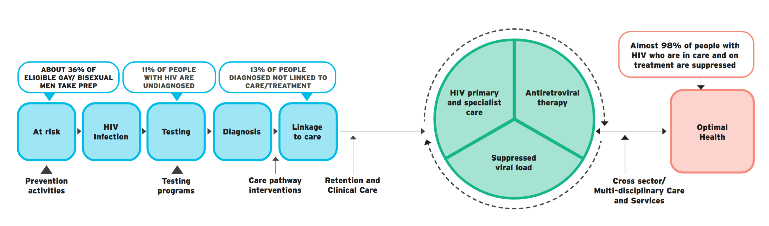

People who use drugs are at high risk of acquiring HIV if they share equipment to inject drugs; however, other (non-injecting) drug use – including the use of alcohol, cannabis and drugs like crystal methamphetamine to enhance sex – can also increase HIV risk by affecting judgement and disinhibiting behaviour. Alcohol and other substance use can result in more sexual risk taking and/or lower adherence to medications such as PrEP and antiretroviral therapy.

