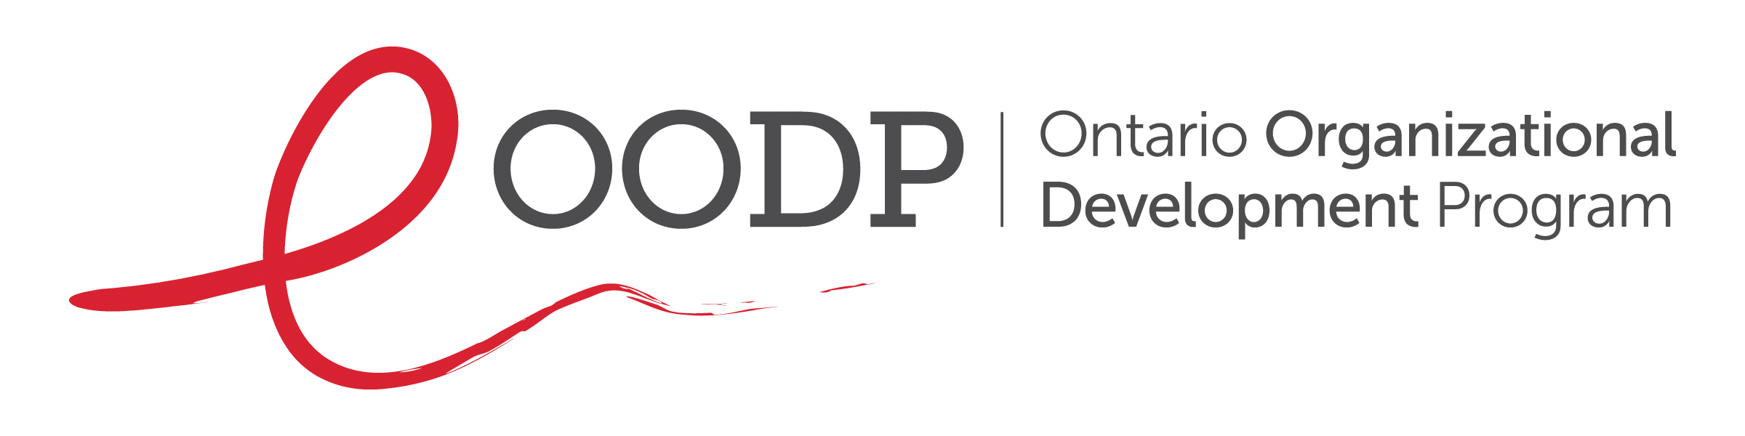

Prepared by: John Miller, OODP Consultant
October 2010
Revised by Dionne A. Falconer, OODP Consultant
May 2026

Board Manual
Annotated Table of Contents

Copyright and Disclaimer Statement

Production of the Board Manual Annotated Table of Contents has been made possible through financial contributions by the HIV and Hepatitis C Programs, Ministry of Health, Ontario.

Copyright to the Board Manual Annotated Table of Contents is held by the Ontario Organizational Development Program (OODP). The OODP acknowledges the contributions of its consultant, John Miller, in preparing this document. The OODP encourages the use of Board Manual Annotated Table of Contents by organizations. However, any such publication shall acknowledge the OODP as the source and John Miller as the Author.

The use of OODP material, with or without amendments, does not constitute approval or endorsement of any organization by either the OODP or the Ministry of Health, Ontario.

Board Manual Annotated Table of Contents

The purpose of a Board of Directors Manual (“Board Manual”) is to provide information that will enable the effective governance of an organization. This includes information on the roles and responsibilities of the Board as a whole and its individual members, as well as information on the organization.

Below is an annotated table of contents that has been designed to help AIDS service organizations (ASOs) create their own Board Manual. Feel free to adapt it to make it your own.

Each section contains the essential items that should be included. Additional items may be added if deemed necessary by the ASO, e.g., a letter of welcome to the Board. The order of the sections and subsections may be changed based on the preferences of the ASO. If an item is not available when the Board Manual is first distributed, the item can/should be added at a later date. Note that some of the policies below include operational elements and so may also be seen at the operational policy level (e.g., in financial policies).

The Board Manual should be provided at the start of a term for each new Board member. It should be made available online via a shared folder or designated website link, e.g. SharePoint, Google Drive, Dropbox. It should also be provided in hard copy to any Board member who requests it. The Board Manual should be reviewed and updated by the Board and/or Governance Committee on an annual basis.

Some of the items identified below are available on the OODP website.

1. Organization Overview
1.1. History – history of the ASO.
1.2. Vision, Mission and Values.
1.3. Truth and Reconciliation Statement.
1.4. Anti-racism, anti-Black Racism Statement.
1.5. Solidarity Statements.

2. Board Model and Processes
2.1. Board Roles and Responsibilities – list of the roles and responsibilities of a not-for-profit Board and individual Board members (see OODP website).
2.2. Board Job Descriptions – job description for an individual Board member and each Board Officer position (see OODP website).
2.3. Board Committees – list of Committees, terms of reference for each Committee and list of members for each Committee
(see OODP website).
2.4. Board Meeting Structure, Processes and Decision-making – outline of how meetings will be run (e.g. who will chair, who will take minutes), process and timelines for finalizing minutes, expectations for follow-up on action items before next meeting, timelines for distribution of meeting agendas and materials, and how decisions will be made.
2.5. Unity of Control – articulation of reporting relationships.
2.6. Executive Director Accountability and Authority.
2.7. Executive Director Job Description.
2.8. Executive Director Performance Management.
2.9. Executive Director Compensation and Benefits.
2.10. Executive Director Succession Plan.

3. Board and Key ASO Policies
3.1. Board Code of Conduct (see OODP website).
3.2. Organizational/ Human Resources Policies Applicable to Board Members – anti-discrimination, anti-harassment and anti-violence; whistleblower policy; conflict of interest; privacy and confidentiality; media communications; health and safety.
3.3. Board Governance Policies – copy of each governance policy passed by the Board of Directors, e.g. meeting attendance and Board volunteer liability policy.
3.4. Human Resources Manual/ Collective Agreement – copy of the current human resources policies and procedures, and/or Collective Agreement.

4. Financial Oversight
4.1. Financial Policies – copy of the ASO’s financial policies and procedures, e.g., cheque signing, expenditure control; approval limits; asset protection and investment guidelines (should also be included in Administration/Operations Manual).
4.2. Budget – budget for the current fiscal year and most recent financial report to the Board.
4.3. Funder Agreements – summary of funding agreements, including name of funder, brief description of what funding covers, amount of funding, period funding covers, deliverables to be achieved, and information on reporting obligations.

5. Resources
5.1. Acronyms – list of commonly used acronyms and their definitions.
5.2. Useful Websites – list of useful websites for the HIV sector, e.g. HIV Resources Ontario and
OACHA HIV Action Plan to 2030

- Appendices
  - Organizational Chart – copy of the current organizational chart.
6.2. Programs and Services – description of the geographic catchment area and program/service descriptions.
6.3. Strategic Plan – copy of the current Strategic Plan and Implementation Plan.
6.4. Annual Report – copy of the most recent Annual Report.
6.5. Executive Director (ED) Board Report – copy of most recent ED Board report (see OODP website).
6.6. Bylaws – copy of the current Bylaws.
6.7. Board Meeting Schedule – list of dates and times for Board meetings for the year.
6.8. Board List – name of each Board member, their position on the Board and their contact information.
6.9. Board Workplan – itemized workplan of Board activities for the year (see OODP website).
6.10. Board Calendar – calendar of items/events relevant for the Board and should include both ASO and Board-specific items/events, e.g. annual PHA picnic, due dates for funder reports and start date for collective bargaining.
6.11. Board Evaluation – tool(s) used for Board self-assessment (see OODP website).
6.12. Board Composition Matrix (see Nominating Committee Resource on OODP website).
6.13. Audited Financial Statements – copy of the most recent audited financial statements.
6.14. Board Meeting Agenda Template (see OODP website).
6.15. Board Meeting Minutes Template (see OODP website).

